

Covid-19 Journal

City, State

Your Name



**Select “Add Page” (+) to begin your journal.**

**[Tap to View and Think:](https://www.youtube.com/watch?v=TAWZF5POrhQ) What is a primary source?**

**[Tap to View:](https://www.youtube.com/watch?v=bwCLySLDoQs&feature=emb_logo) Wisconsin Historical Society challenge**

**[Think](https://www.youtube.com/watch?v=TAWZF5POrhQ)**

**[View](https://www.youtube.com/watch?v=bwCLySLDoQs&feature=emb_logo)**

**Create**

**Start Here**

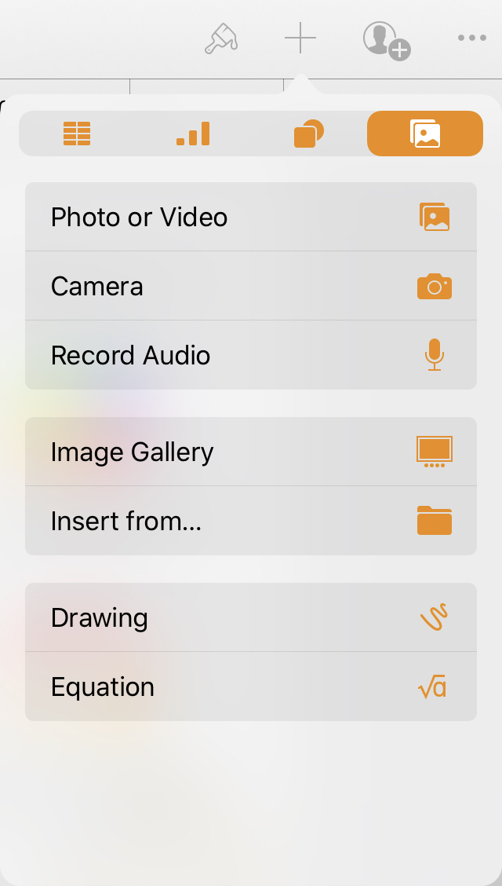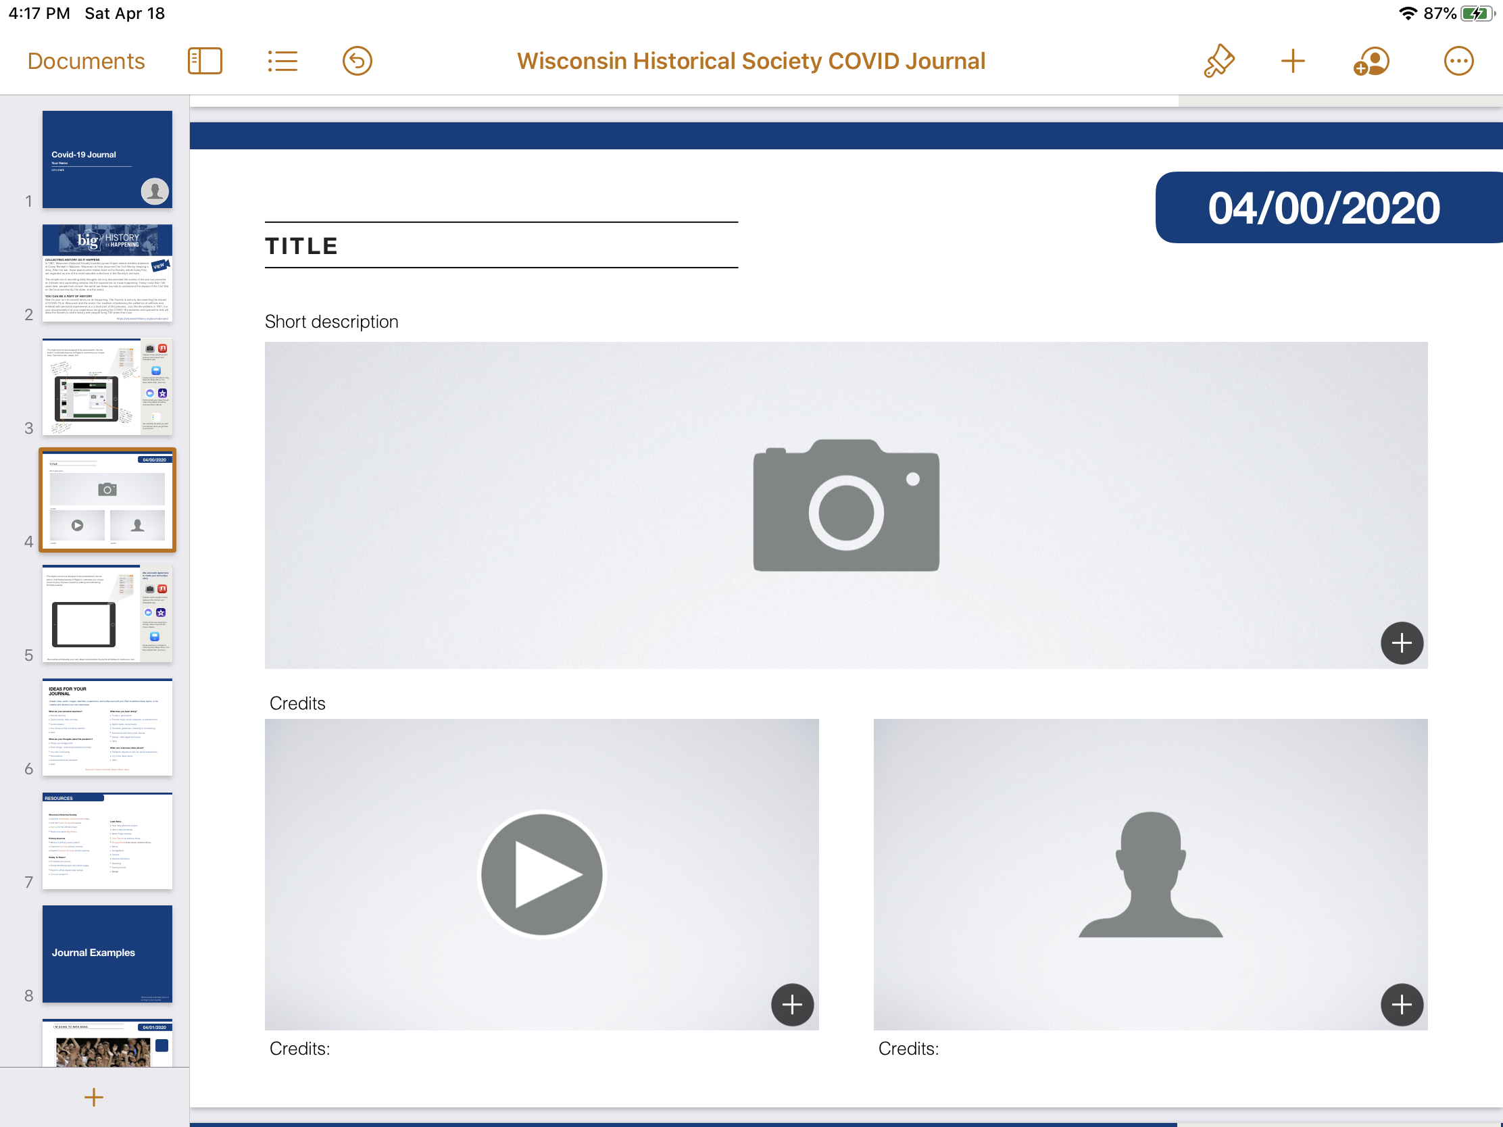

This digital journal was designed to be personalized. Use the built-in, multimedia features of Pages to customize your unique Covid-19 story. Express yourself by adding and subtracting template features.

**Mix and match digital tools to create your own unique story.**

Create sketches or animations using Keynote’s Magic Move, Line Draw, Motion Path, and more.

Capture media using the built-in features of the Camera and PhotoBooth app.

Communicate your experience through video using tools like Clips or iMovie.

Be creative and develop your own ideas to personalize the journal templates or create your own.



# Ideas For your Journal

**What are your personal reactions?**

* Remote learning
* Typical chores, daily activities
* Social isolation
* Your illness or that of a family member
* Other

**What are your thoughts about the pandemic?**

* Things you struggle with
* Silver linings - surprisingly positive outcomes
* Your role in the family
* Rumors/facts
* Politics
* Science behind the pandemic
* Other

**What have you been doing?**

* To stay in good spirits
* Favorite music, movie, television, or entertainment
* Digital media, social media
* Pandemic guidelines - following or not following
* Interactions with family, pets, friends
* Games - both digital and board
* Other

**What can I interview others about?**

* Pandemic impacts on job, life, social relationships
* Any of the ideas above
* Other

*Create primary source video, audio, images, sketches, screenshots, and written text with your iPad to address these topics, or be creative and develop your own responses.*

[View More Ideas](https://wisconsinhistory.org/journalproject#block)

**Wisconsin Historical Society**

* View the [introductory announcement](https://www.youtube.com/watch?v=bwCLySLDoQs&feature=emb_title) video.
* Visit the [Covid-19 Journal](https://wisconsinhistory.org/records/Article/CS16333) website.
* [Sign up](https://uwmadison.co1.qualtrics.com/jfe/form/SV_7ZDR6zdMGNNKHxX) for the official project.
* Read more about [Big History](http://www.apple.com).

**Primary Sources**

* What is a [primary source](https://drive.google.com/file/d/1txrt86az_o843ufuZ8-FDWiIa9LjW07X/view?usp=sharing) video?
* Examine [Each Day](https://wisconsinhistory.org/records/Article/CS16329) primary sources.
* Explore [Freedom Summer](https://www.wisconsinhistory.org/Records/Article/CS15293) primary sources.

**Ready To Share?**

* Proofread your journal.
* Delete template/project description pages.
* Export to ePub (digital book format).
* Turn your project in.

**Learn More About**

* [Pages](https://support.apple.com/guide/pages-ipad/intro-to-pages-tane9d8593b0/ipados)
* [Clips](https://youtu.be/EwGTu8Jf01w)
* [EncyClipPedia](https://www.youtube.com/playlist?list=PLgJU-0-jE8cpY_kWcQqcBvjUN0He9KRGT)
* [iMovie](https://www.dongoble.com/editing-with-imovie-for-ios.html?fbclid=IwAR1WnKRyHzkjjyA7QepNabA9CyaHFQzr6H4-NE0VXp3-B6E8JTXGHFPi5Kg)
* [Bounce](https://www.youtube.com/watch?v=wgkZwpM6Qrs) a Live Photo
* [Keynote animations](https://www.youtube.com/watch?v=ZO7Dik4kIoI)
* [Tracing a photo](https://vimeo.com/347514924)
* [Screenshot MarkUp](https://www.youtube.com/watch?v=9_qCDnrTIUw)
* [Design](http://www.apple.com)

**Resources**

Journal Examples

*Delete these examples prior to turning in your journal. They are here to show just a few examples of what might be considered a “journal entry.”*



**04/01/2020**

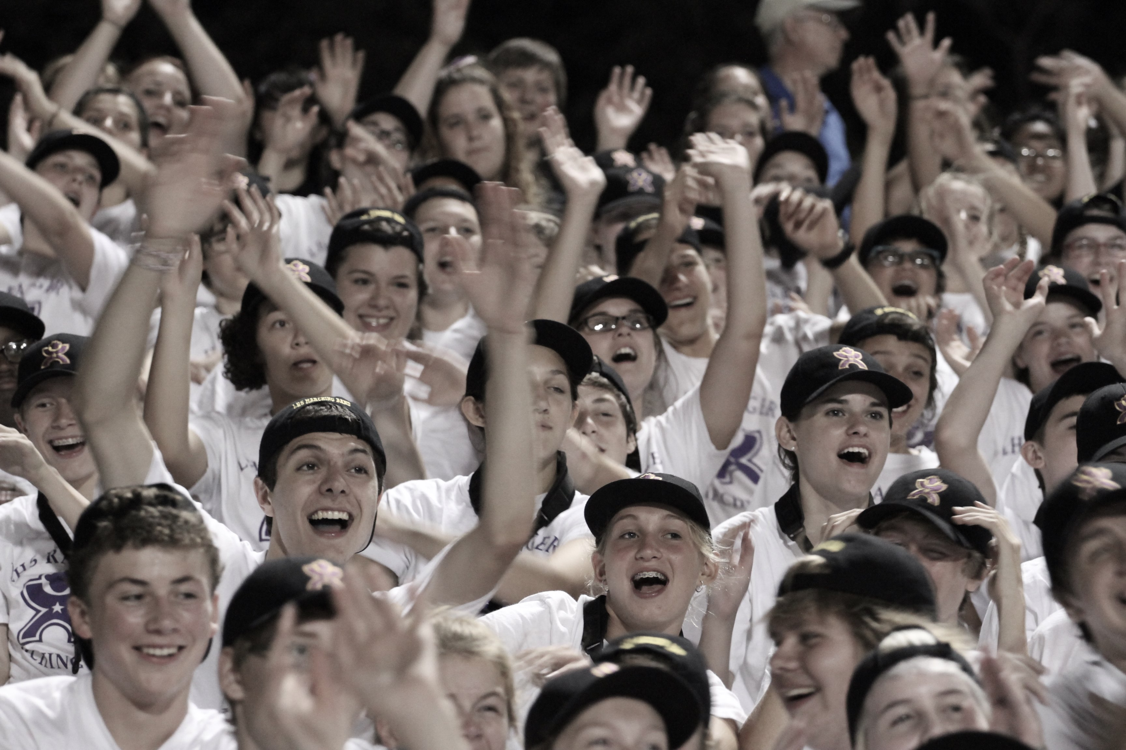

This is a photo from before the pandemic.

## I’m going to miss band.

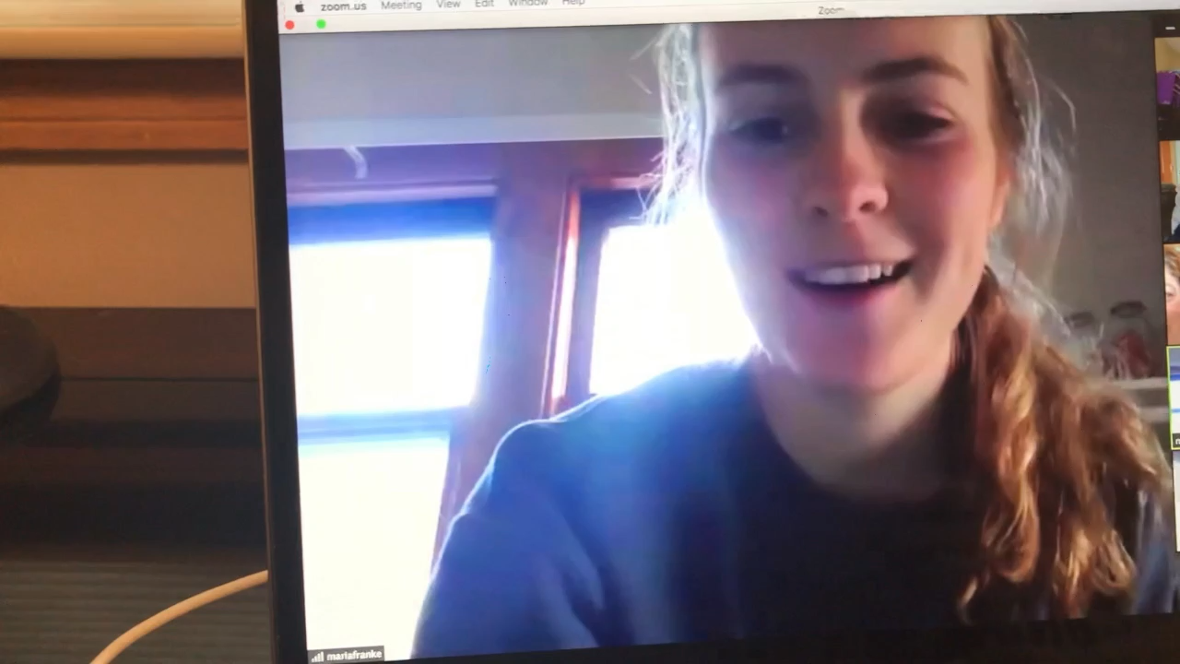

**04/02/2020**

Interview conducted via Zoom.

## What will you tell your kids about this pandemic?

Tap or select the still image to play the interview with Maria Franke.

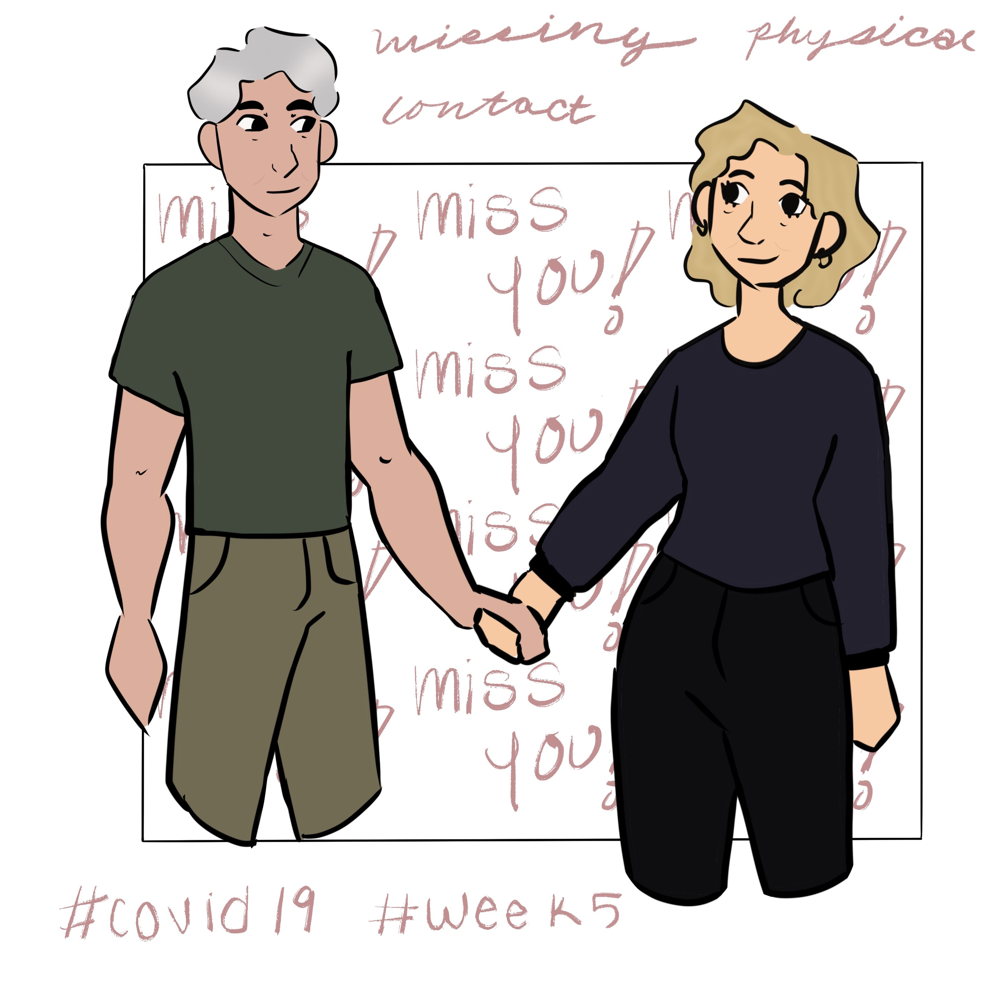

**04/03/2020**

## My drawing about what I miss: physical contact!!! 😢

**04/04/2020**

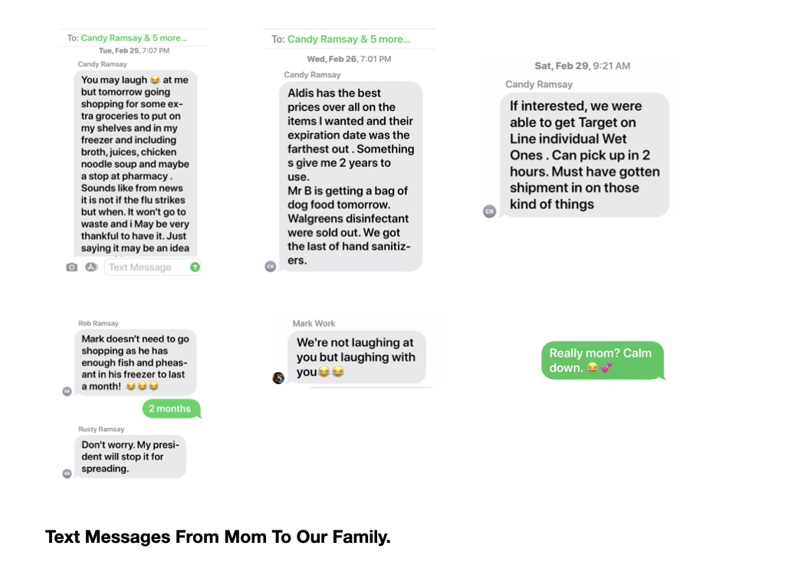

Screenshots from my phone.

## My mom is always right!

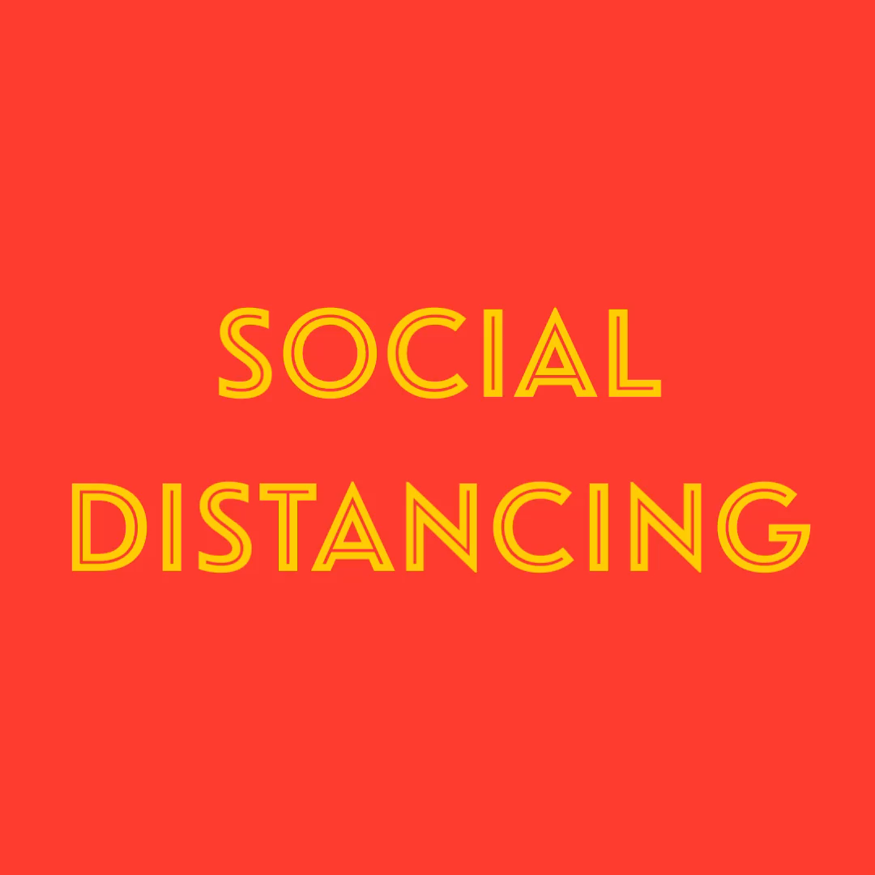

**04/05/2020**

Photos from my iPad photo library edited in Clips.

## It’s confirmed. I am an introvert.

Tap or select the still image to play the video at left.

**04/06/2020**

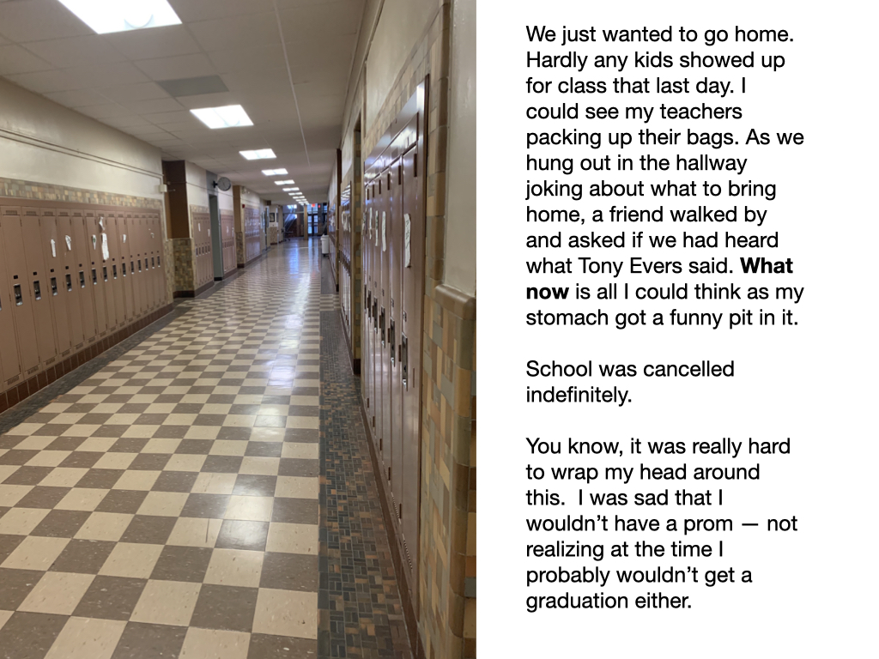

My school hallway as I glanced back the last time.

## What now?

We just wanted to go home. Hardly any kids showed up for class that last day. I could see my teachers packing up their bags. As we hung out in the hallway joking about what to bring home, a friend walked by and asked if we had heard what Tony Evers said. **What now** is all I could think as my stomach got a funny pit in it.

*School was cancelled indefinitely.*

You know, it was really hard to wrap my head around this. I was sad that I wouldn’t have a prom — not realizing at the time I probably wouldn’t get a graduation either.

This journal was created by Jeanne Halderson with the express intent that students and teachers could modify it to fit the needs of their classrooms.

Follow Jeanne on Twitter @JeanneHalderson

jeannehalderson@gmail.com